Abhay Patil Cloud Exam

ID – 240840325002

Q1.

PART-1

Step -1: Go to IAM Dashboard

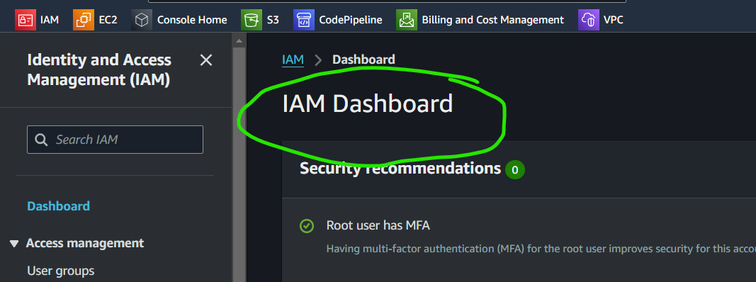

Step 2: Create User

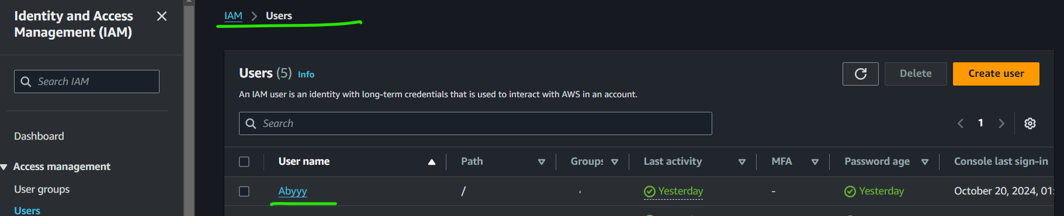

Step 3: Fill user details

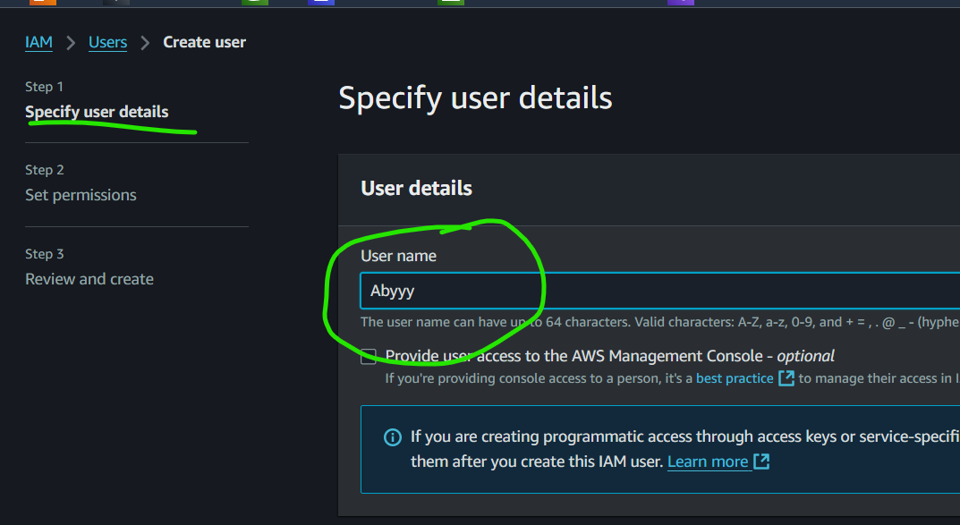

Step 4: Can either use groups or directly apply the permissions for the user.

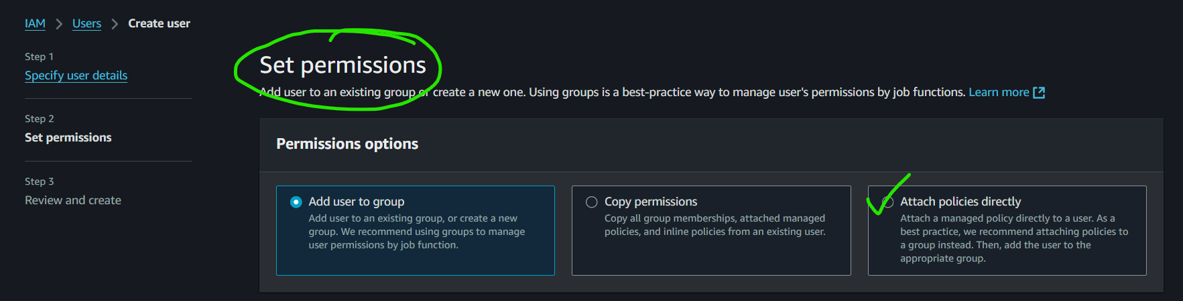

Step 5: Select directly policies

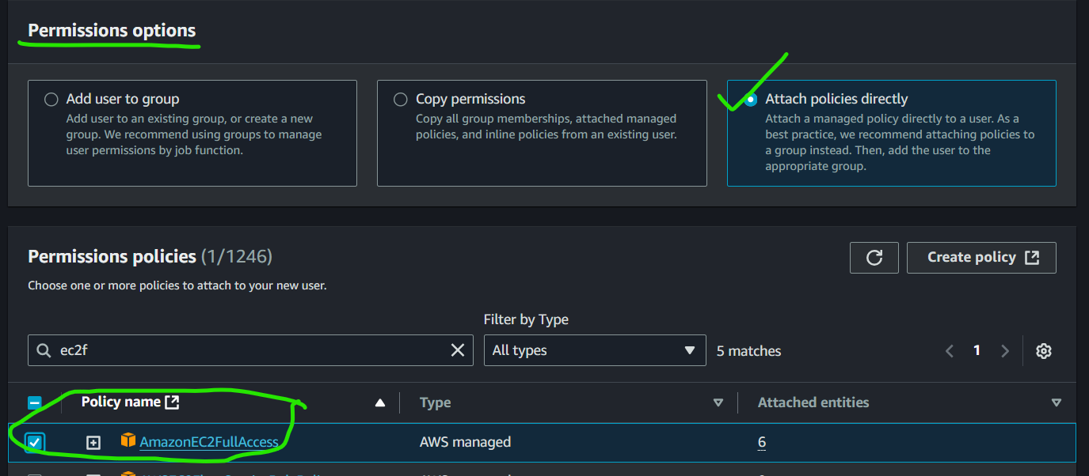

Step 6: Review your user profile

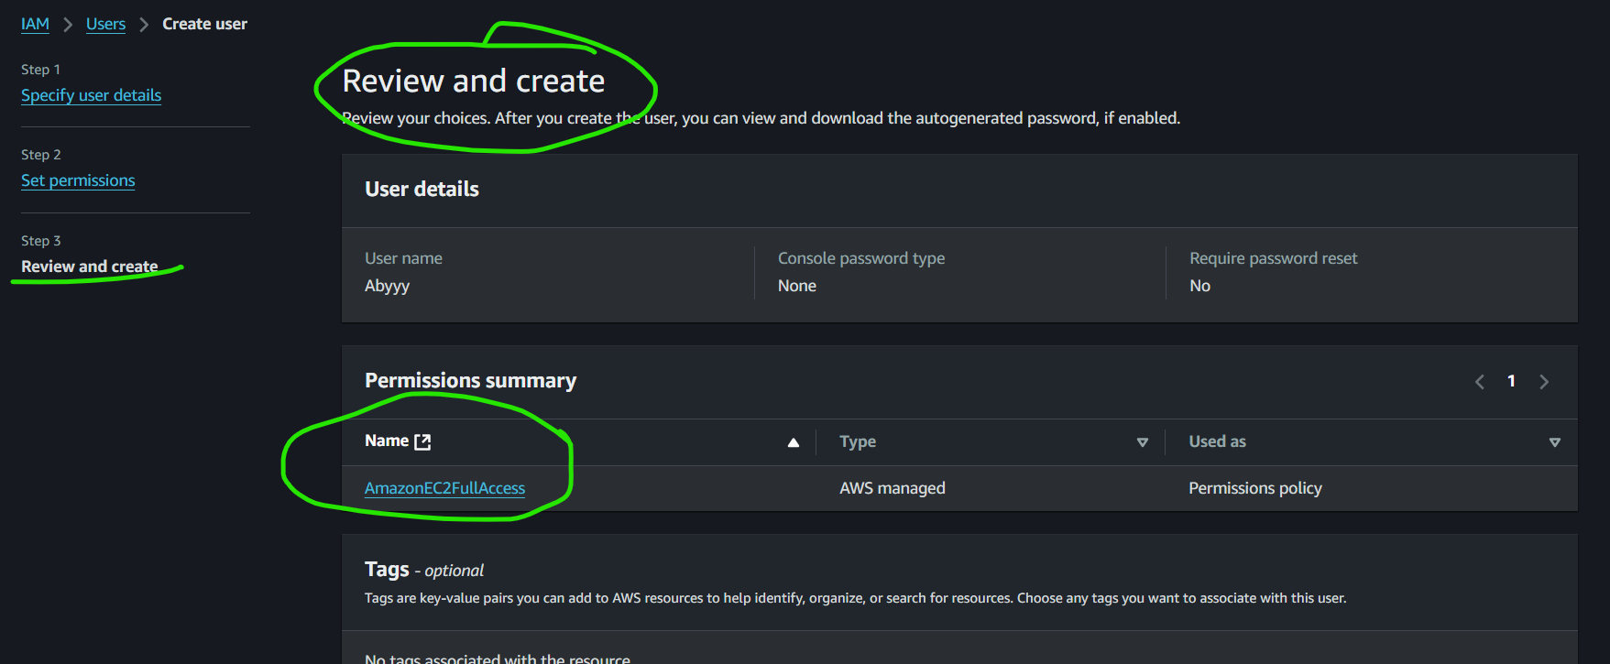

PART - 2

Step 7: go to user and select security credentials, then enable console access

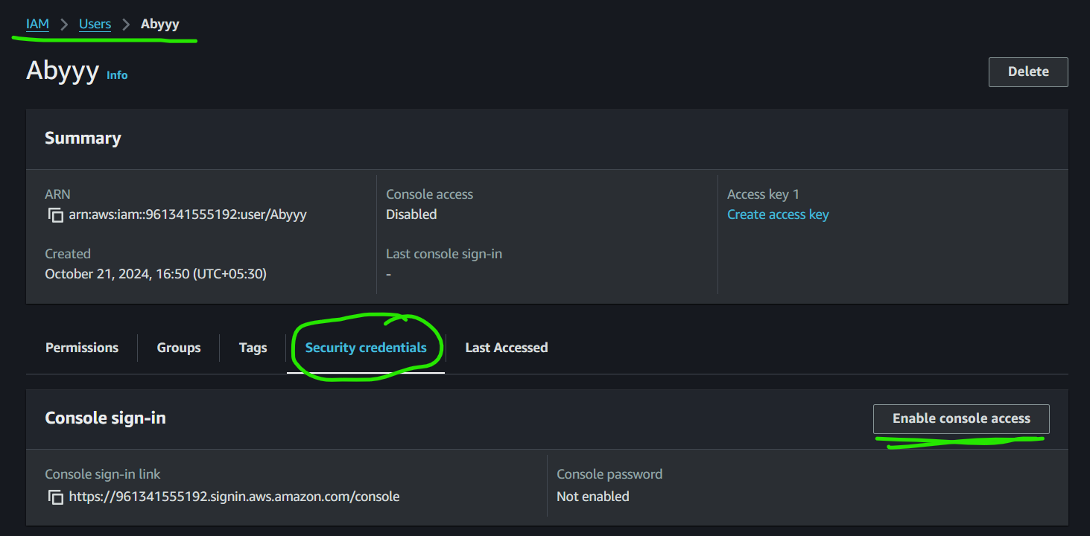

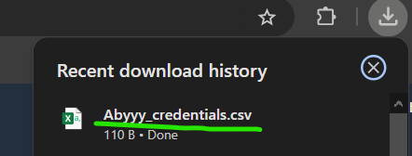

Step 8: Create Access Key

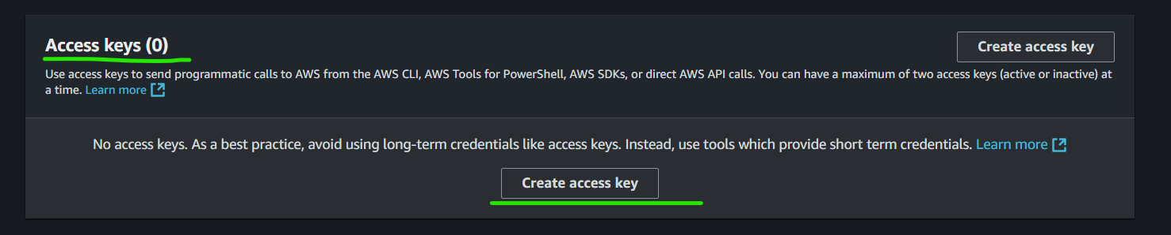

Step 9: Select 3rd option

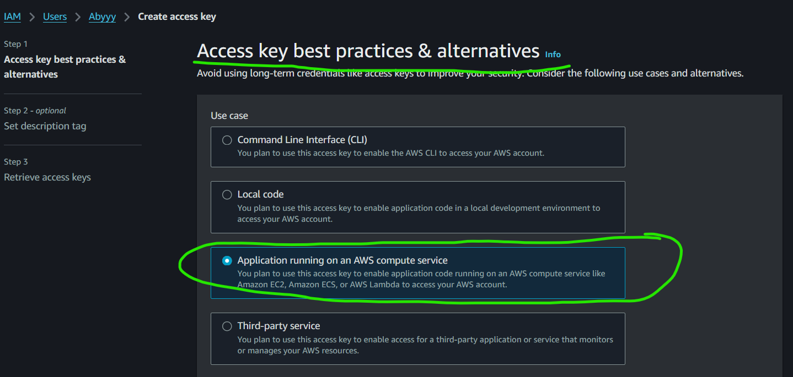

Step 10: Write your description, it is optional though.

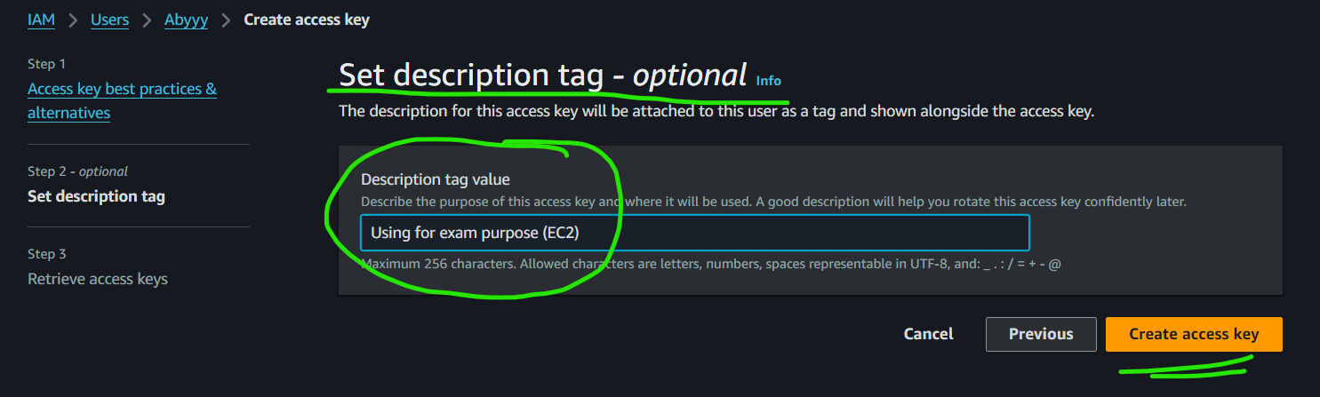

Step 11: Download .csv file

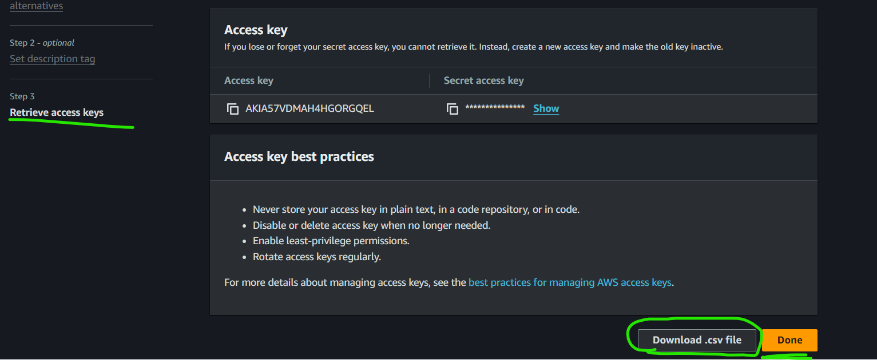

Step 12: For new user login , copy this link:

(https://961341555192.signin.aws.amazon.com/console)

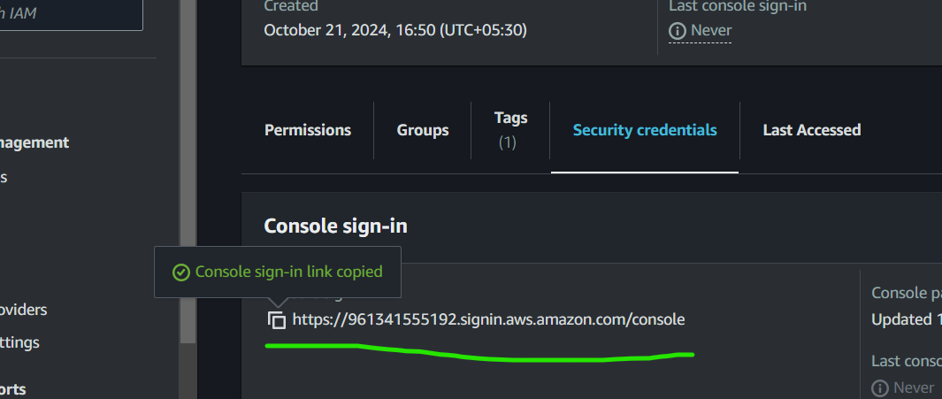

Step 13: New browser, copy link and then this is the website

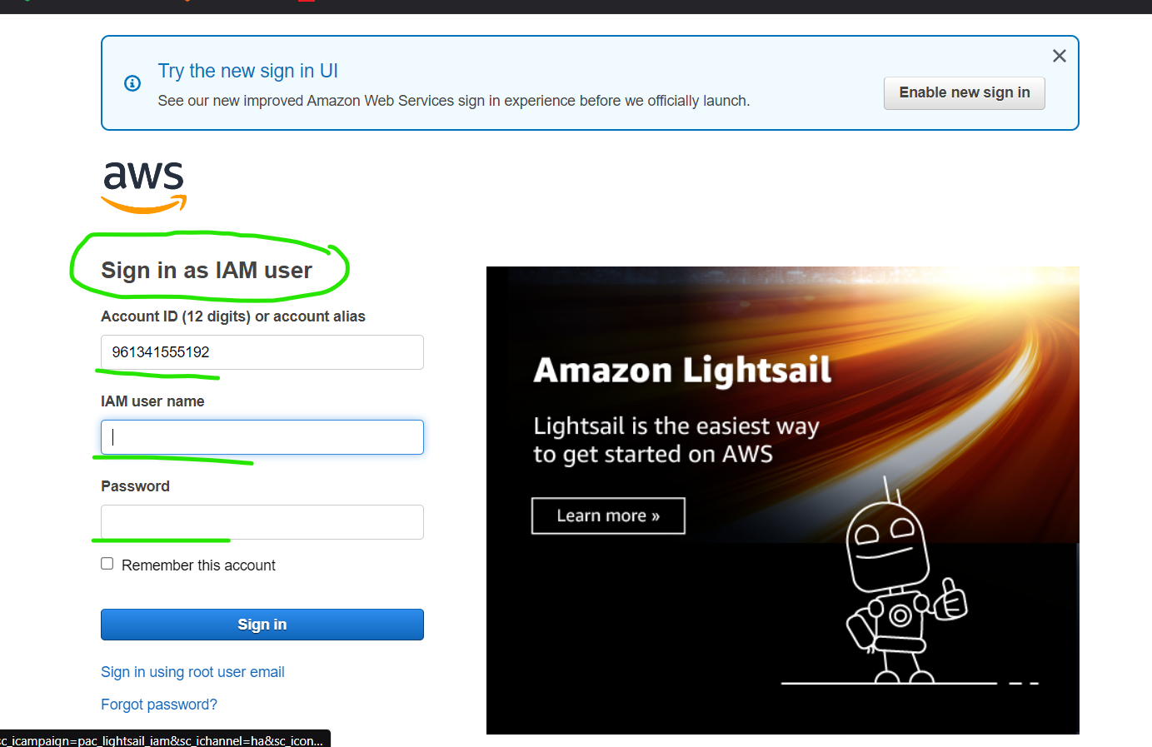

Step 14: These are the login credentials of our new user.

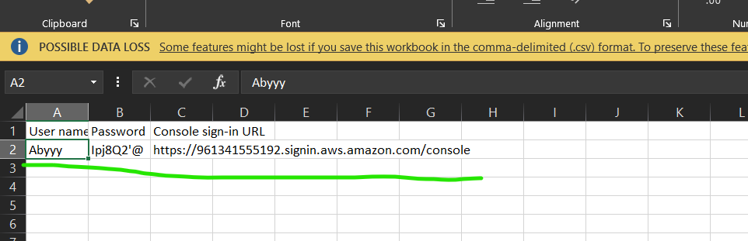

Step 15: This is the website after logging from the IAM user.

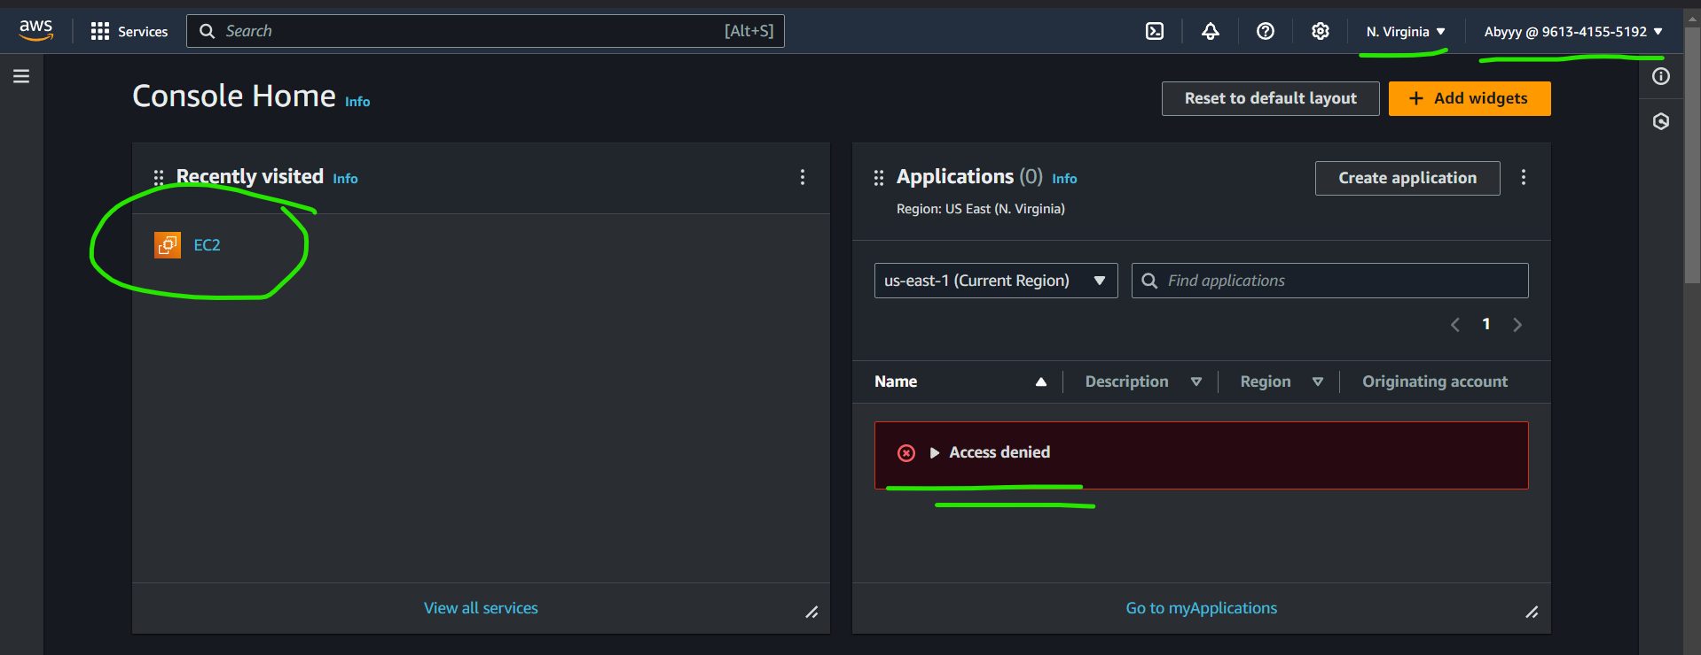

Step 16: Create Instance

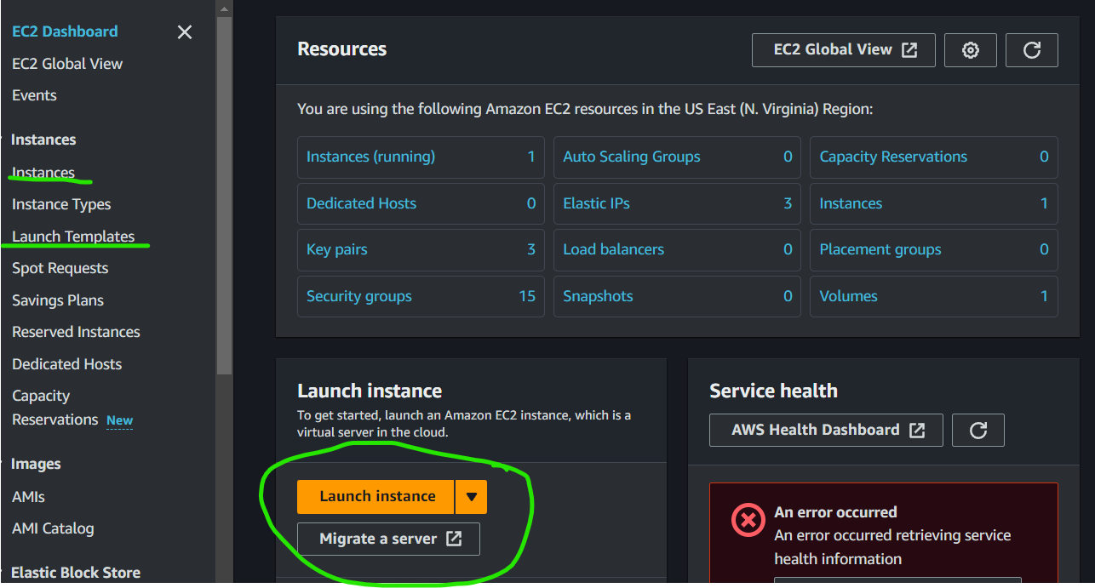

Step 17: write your instance name

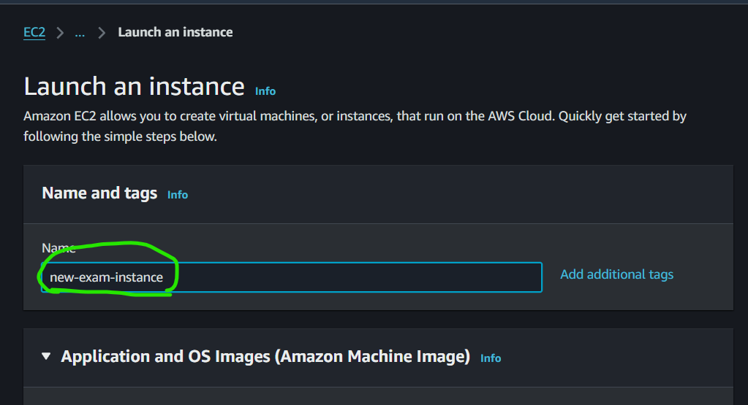

Step 18: select “AWS Linux” AMI

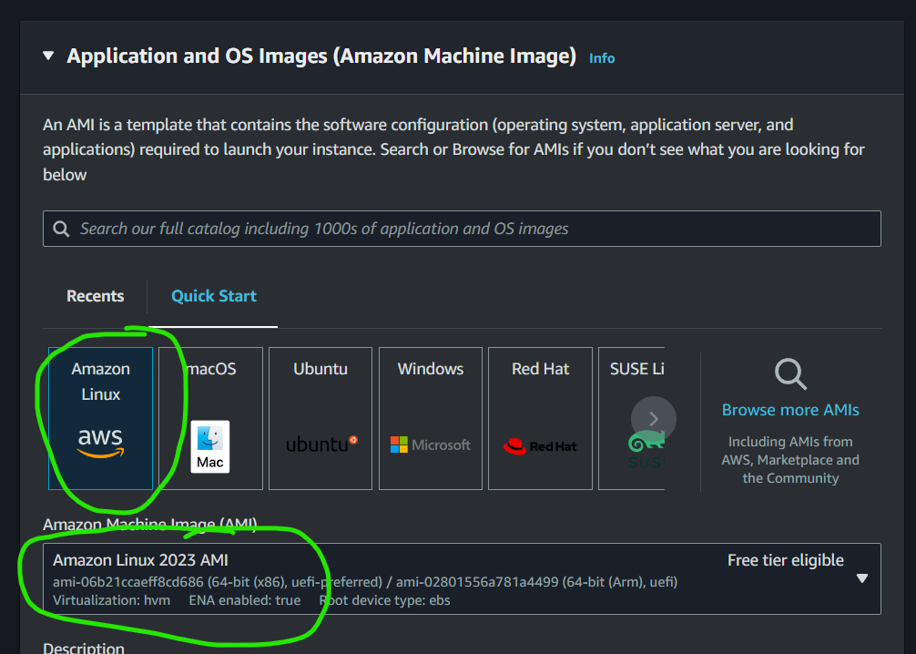

Step 19: “t2.micro” as it is free and we don’t have much requirement of heavy computations or large storage for selecting else.

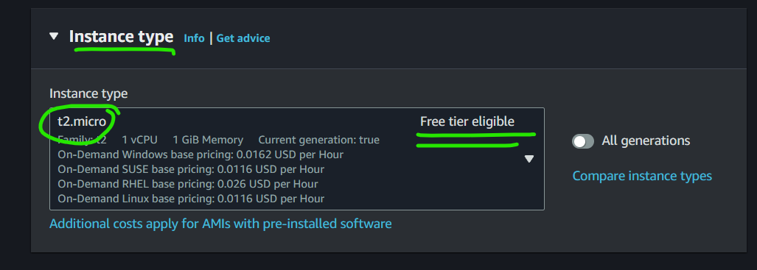

Step 20: Generate key-pair

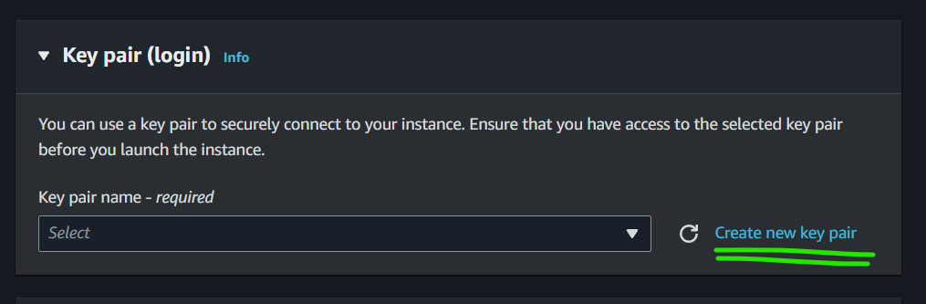

Step 21: give name to it, select .ppk extension so we can use it with PuTTY in future.

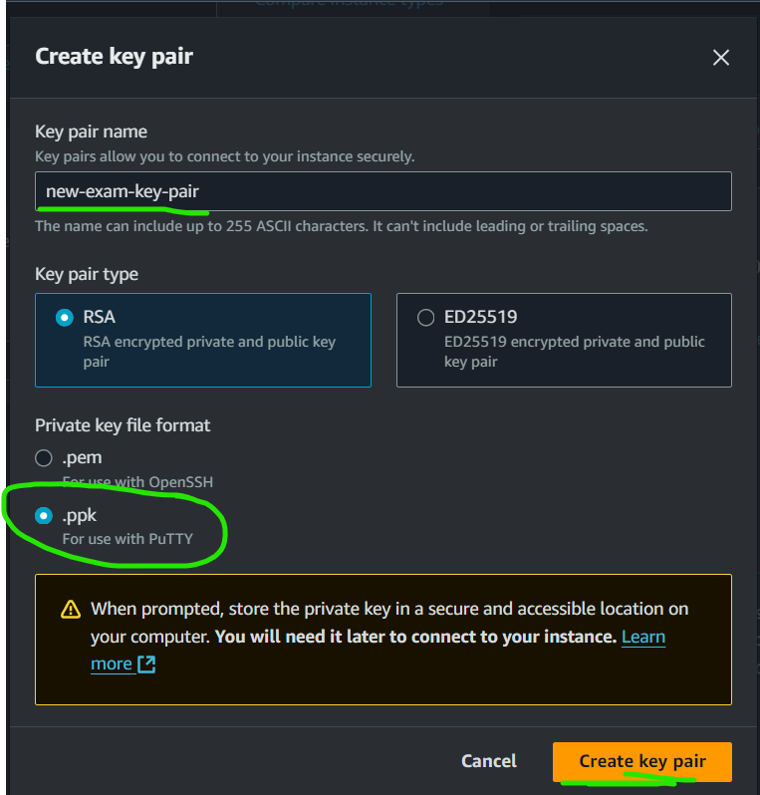

Step 22: Allow SSH and HTTP ports

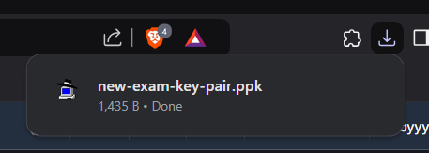

Step 23: For the permission of ports of SSH and HTTP

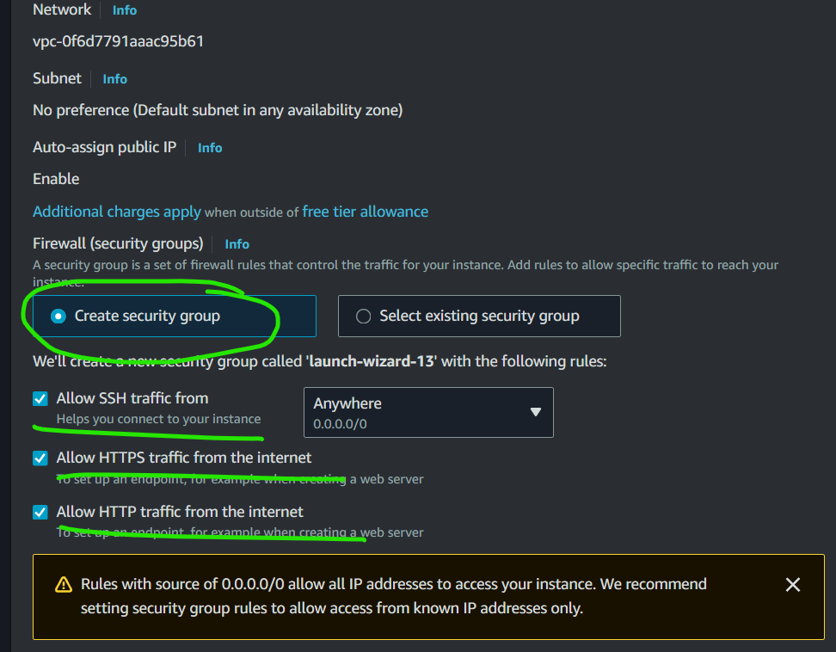

Step 24: Launch Instance

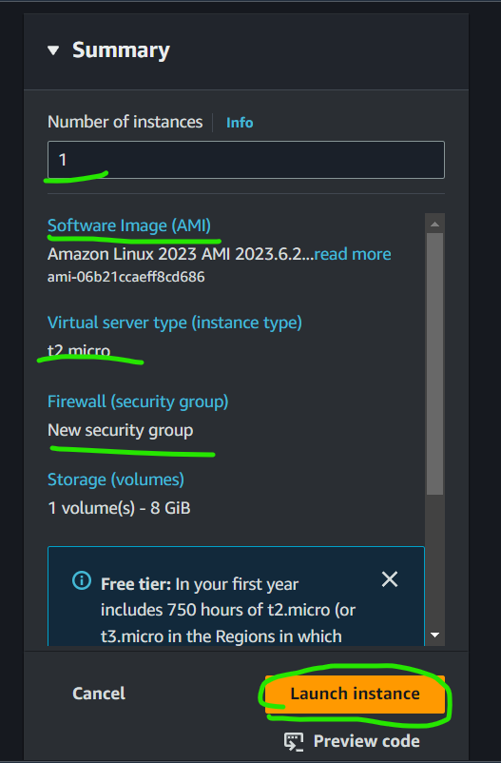

Step 25:

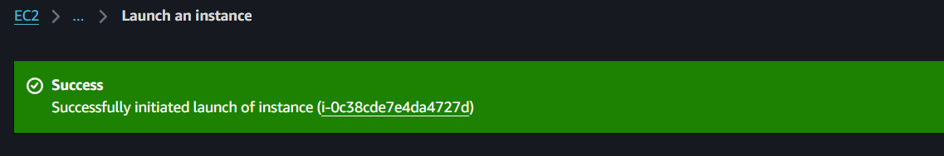

Step 26:

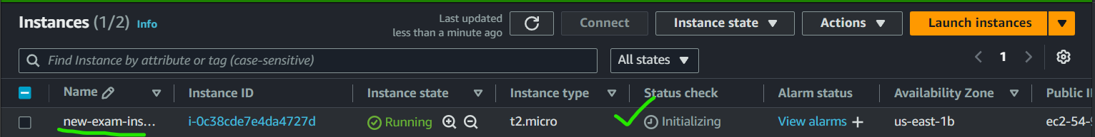

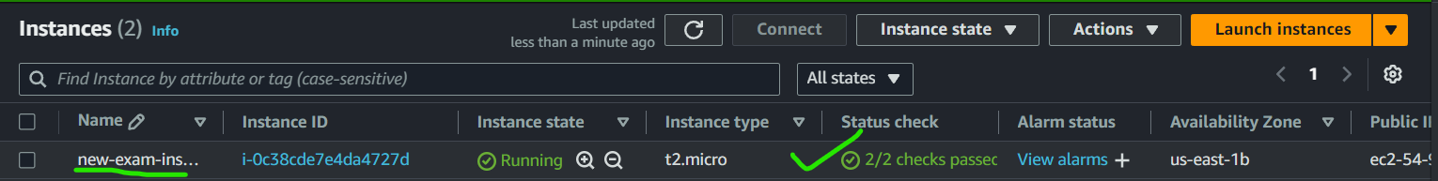

Step 26-A] To verify we can use IAM Simulator

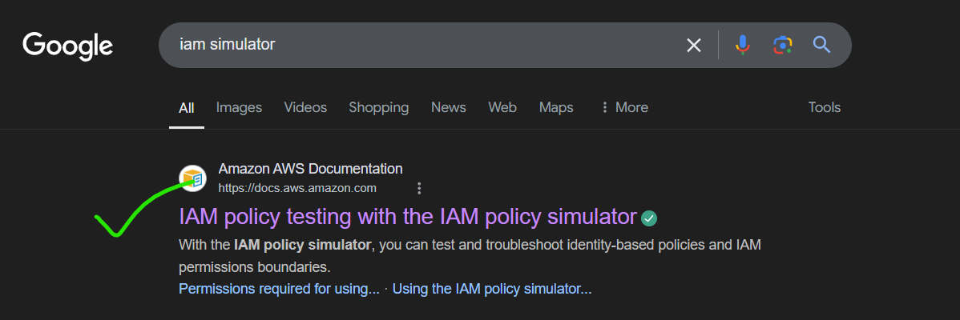

Step 26-B]

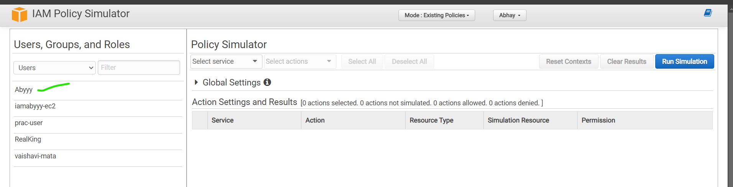

Step 26 – C] It has full access

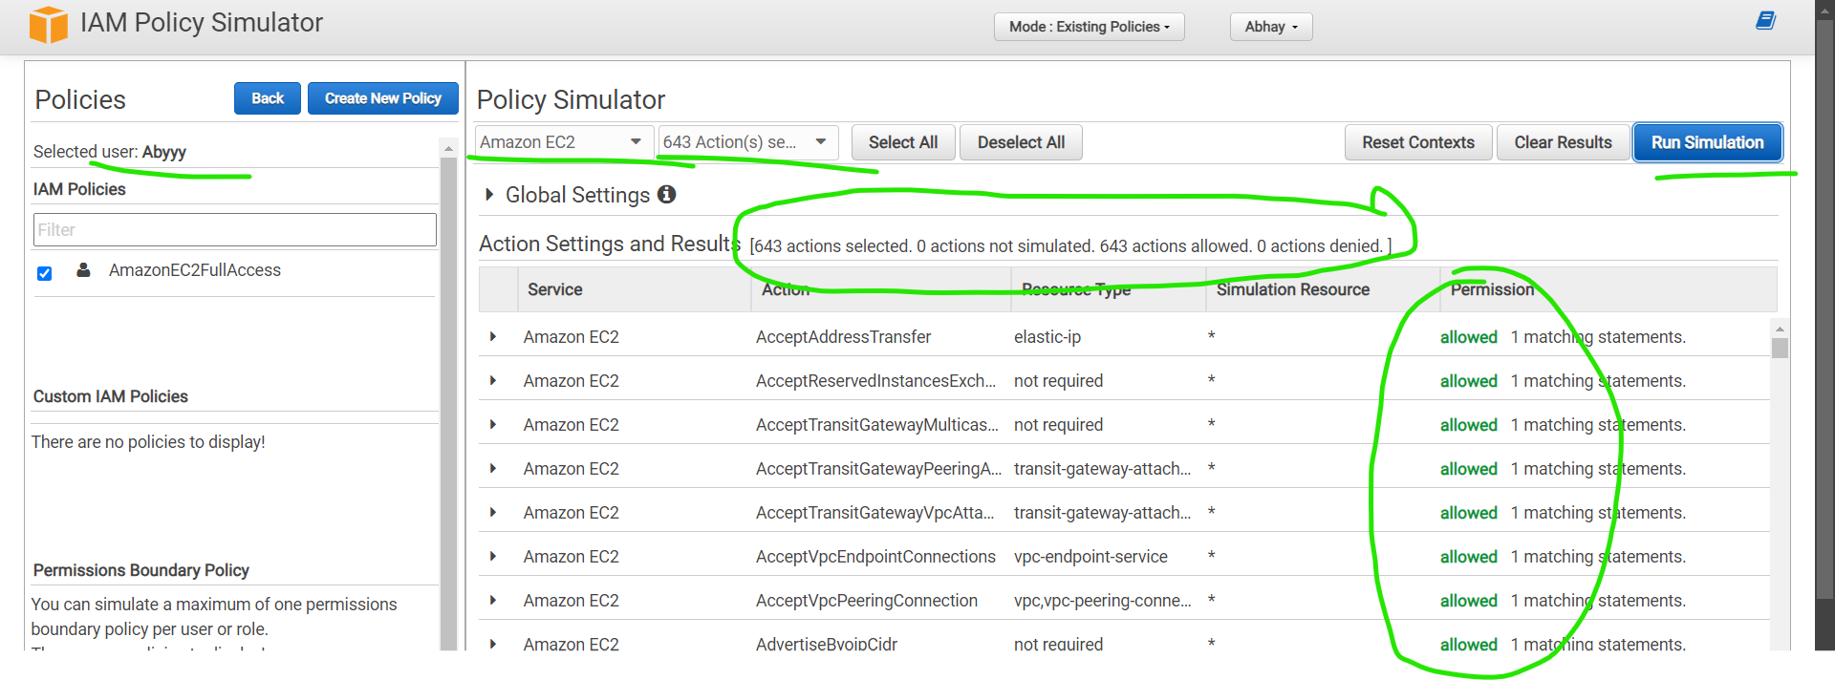

PART – 3

Step 27: Created HTML page in VS Code for the basic upload task in S3 Bucket

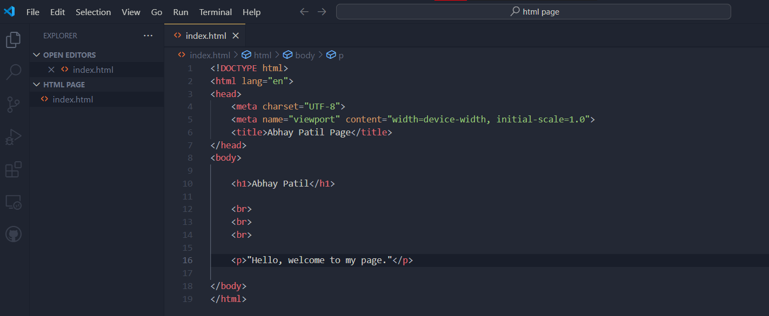

Step 28: Create bucket

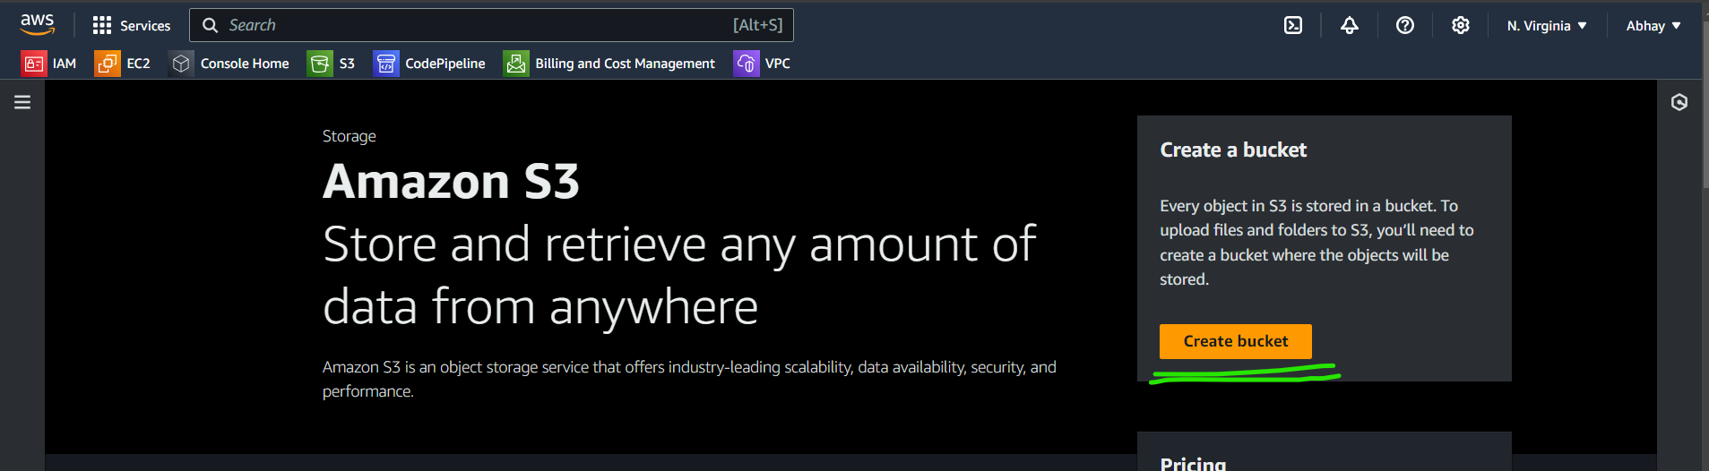

Step 29: Give name to it

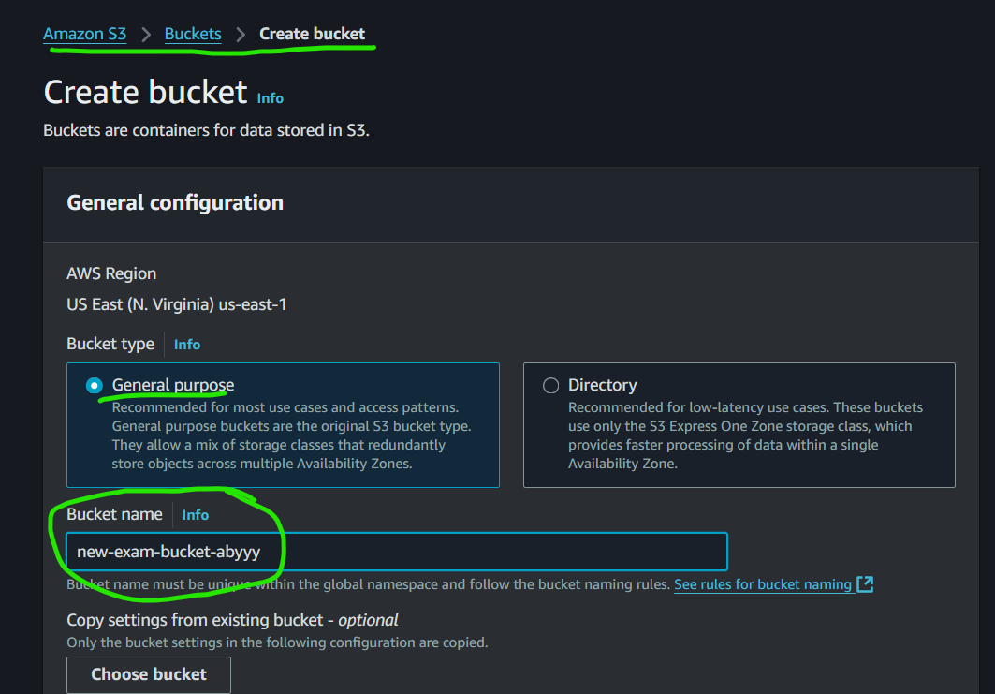

Step 30: Select ACL enabled

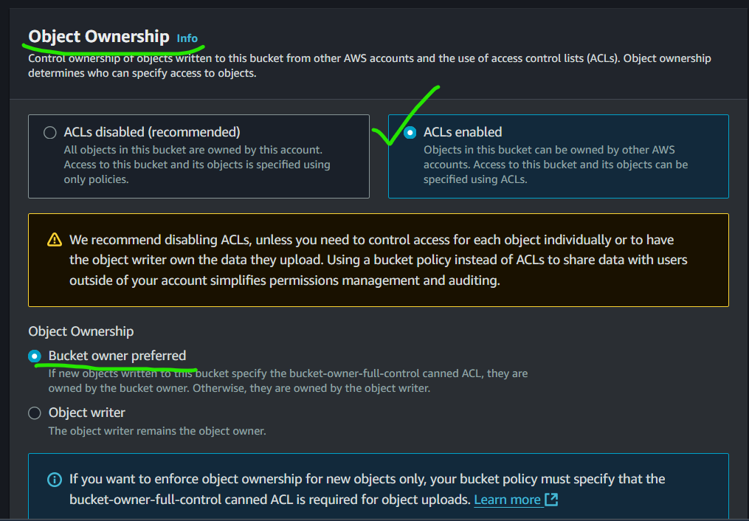

Step 31: Uncheck for public visibility

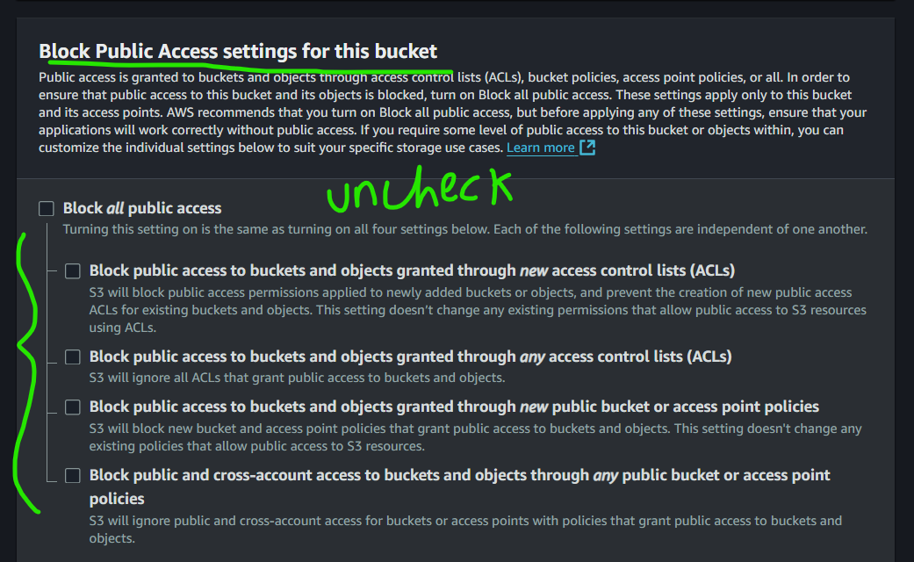

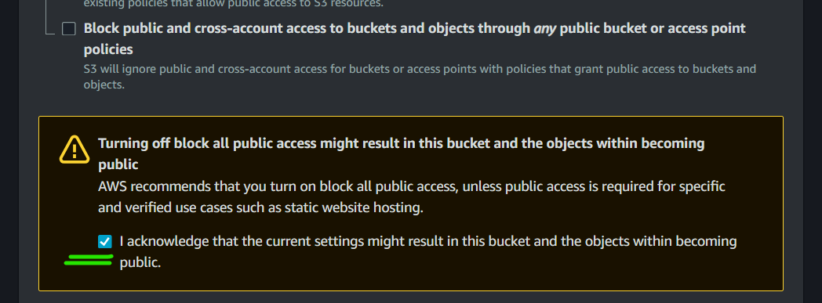

Step 32: Bucket versioning if you need constant updates made in the file reflect it in your S3 bucket

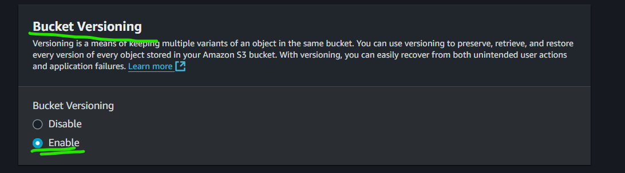

Step 33: Create bucket

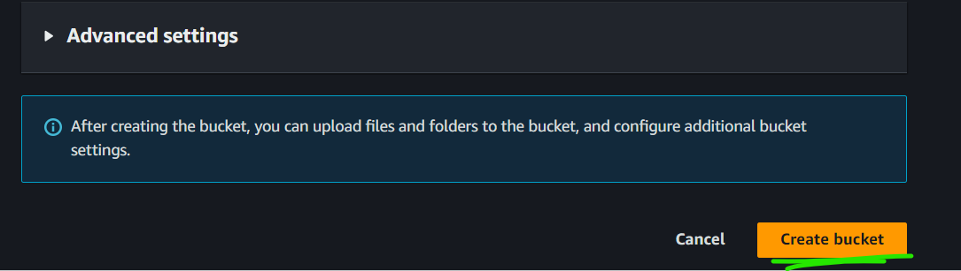

Step 34: bucket is created

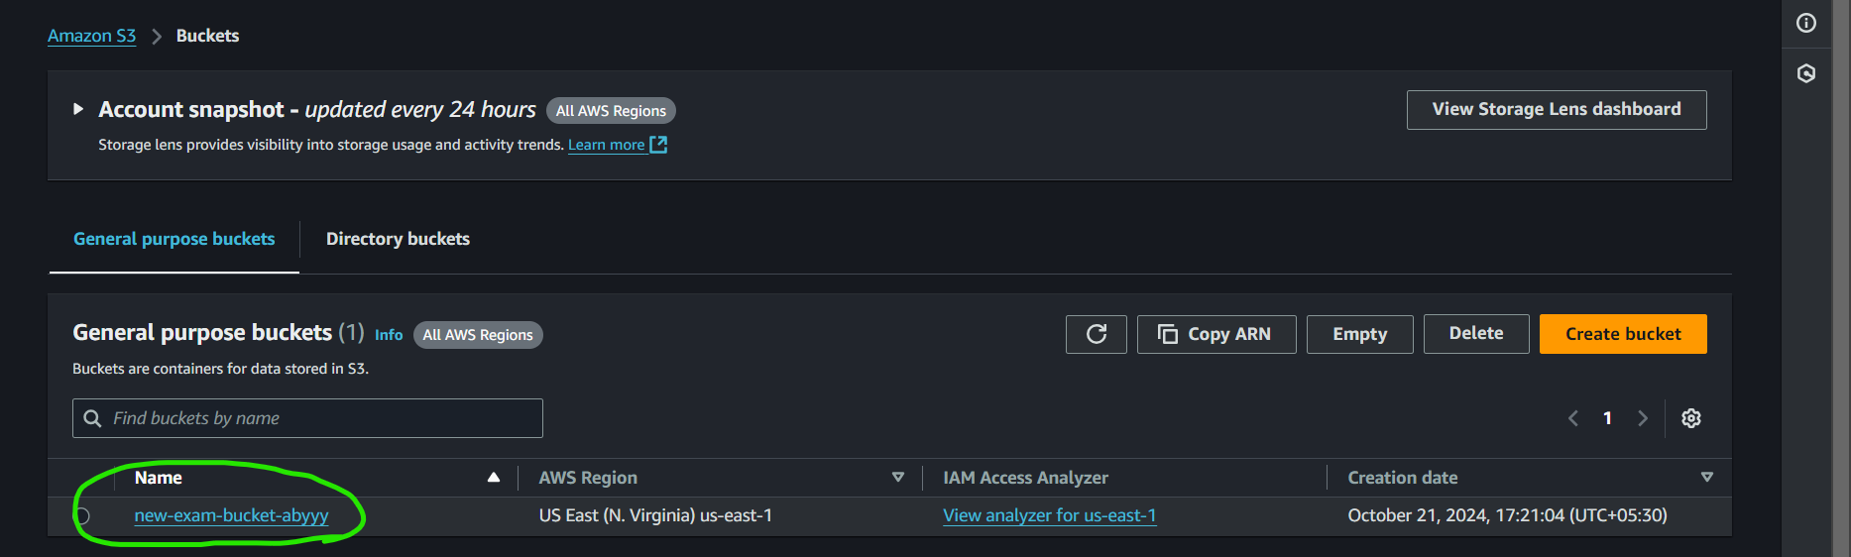

Step 35: For uploading files. For this exam, I am uploading HTML file.

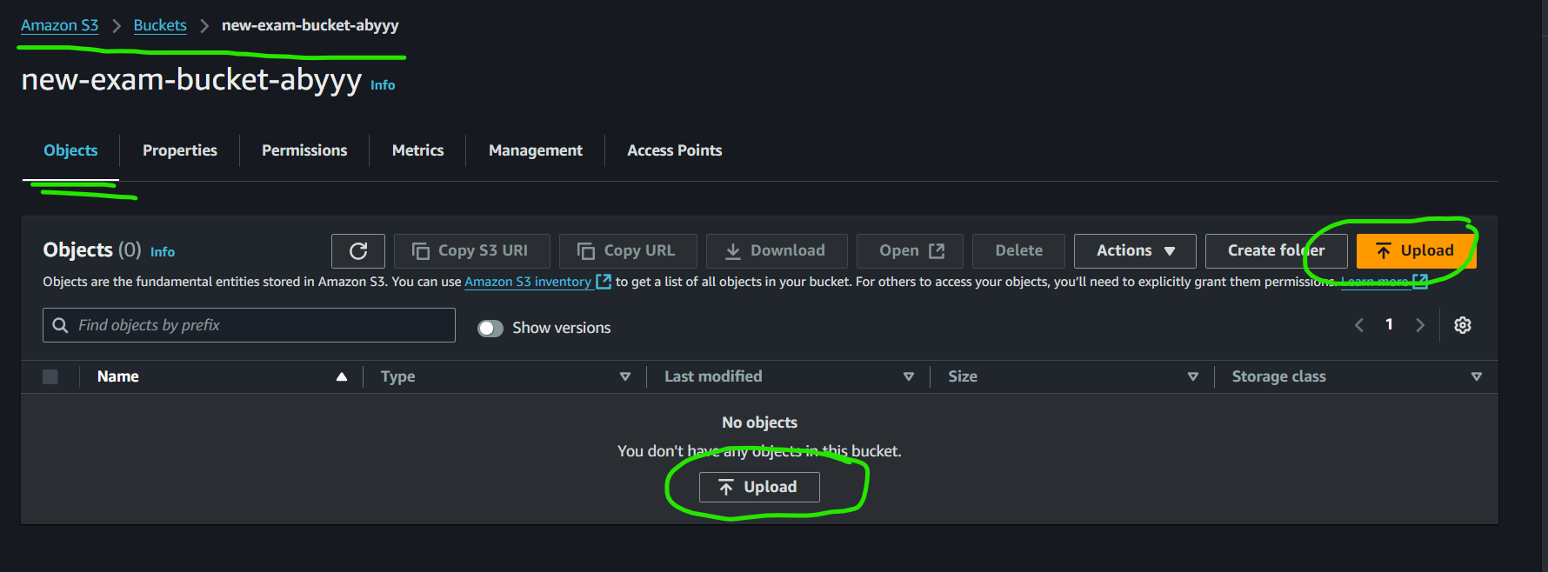

Step 36: Here, I “drag N drop” the file, you can also upload it by clicking the “Add file” or “Add folder” button.

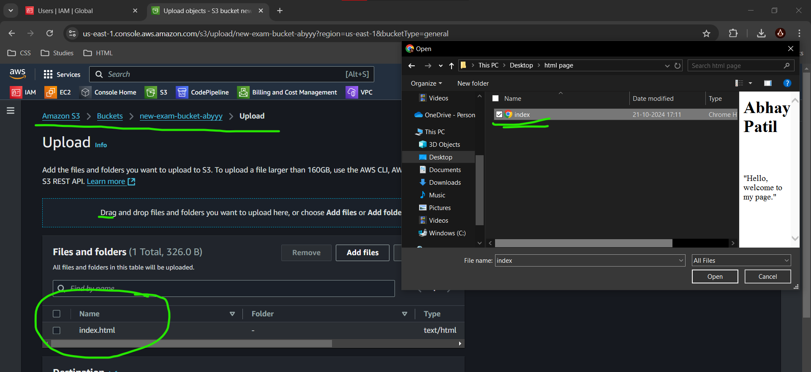

Step 37:Upload

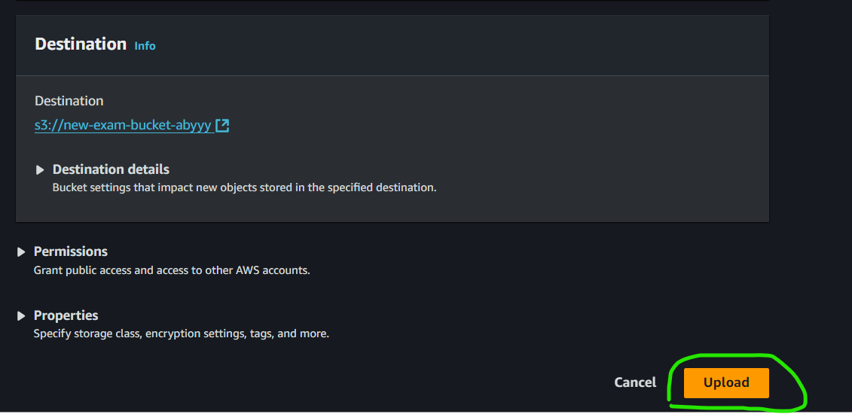

Step 38: Uploaded!!

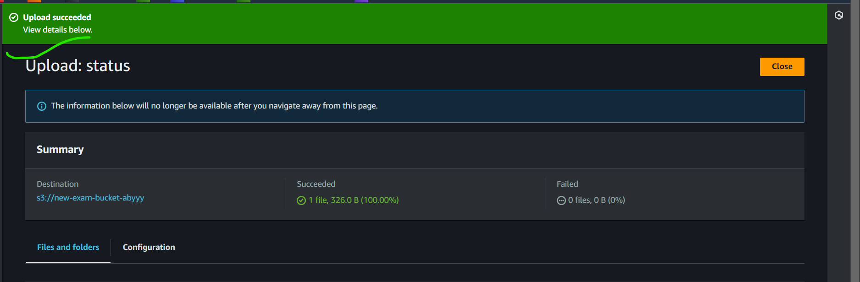

Step 39: Now make it public using ACL to visit the site publicly.

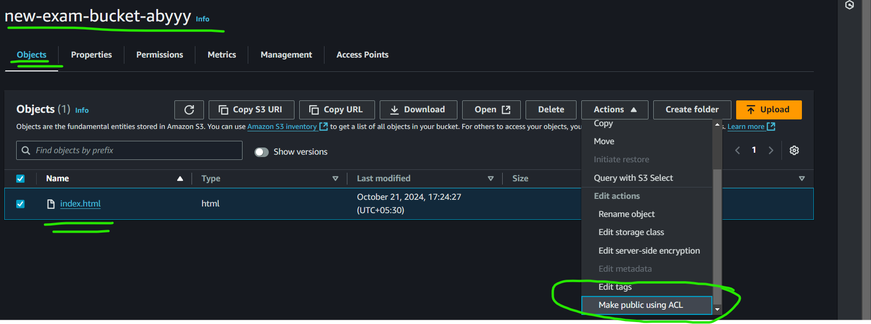

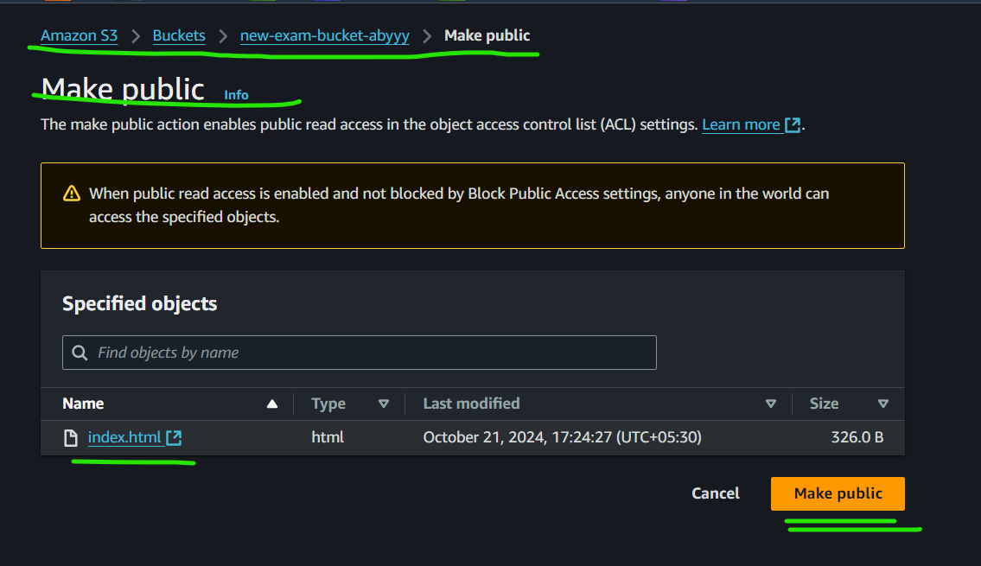

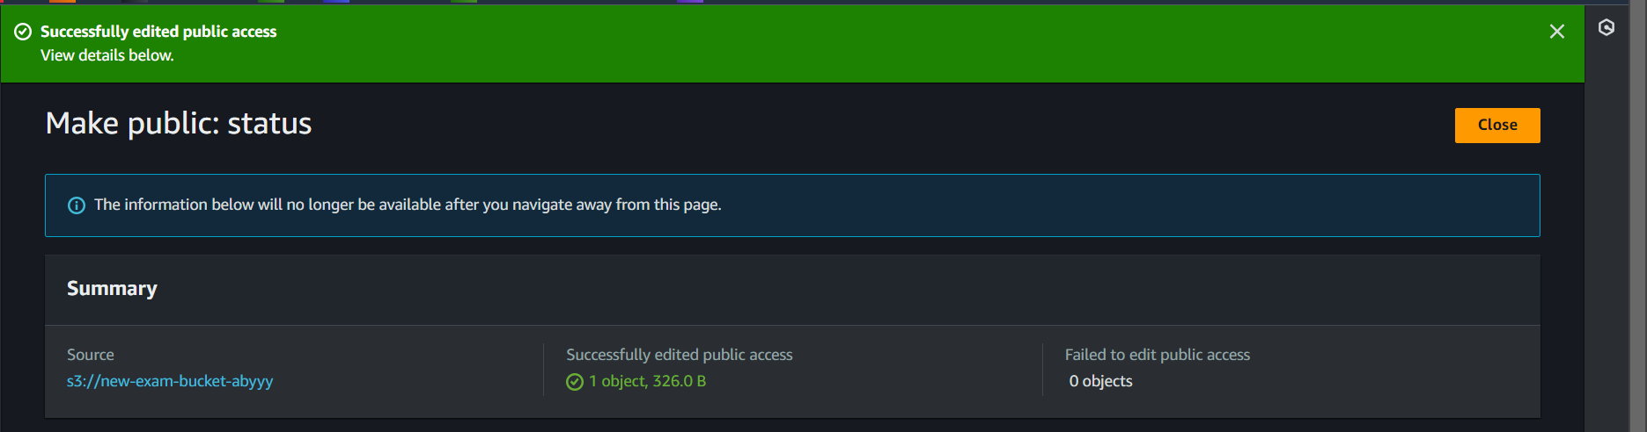

PART - 4

Step 40: Since we have made it public, let’s now access the website through its Object URL.

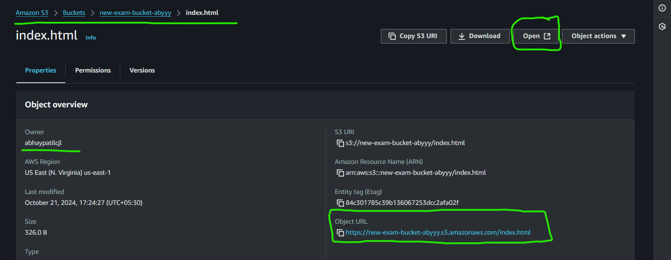

Step 41: URL Copied

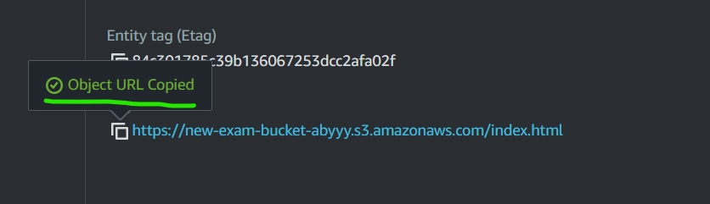

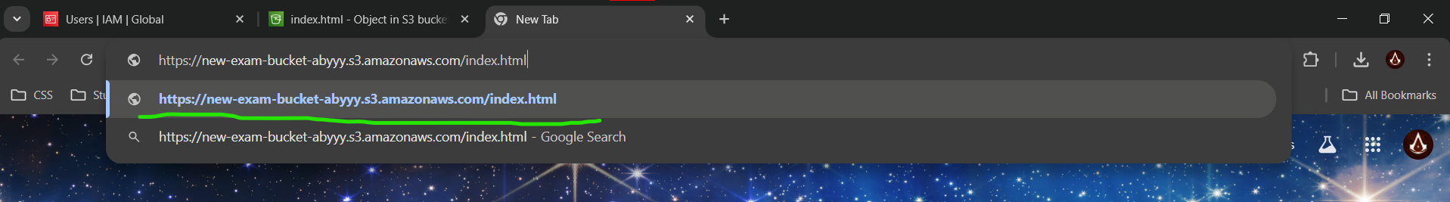

Step 42: The web page is visible through Object URL and is publicly available.

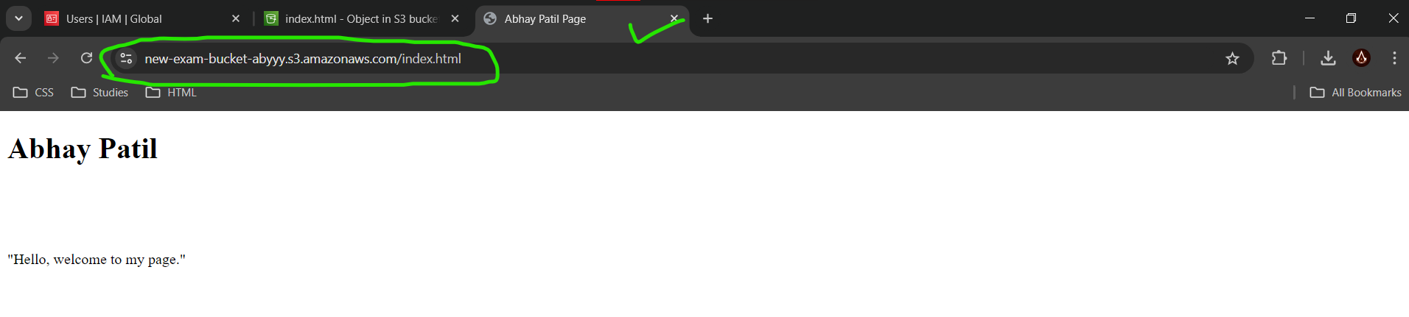

Abhay Patil Linux Exam

Q1.

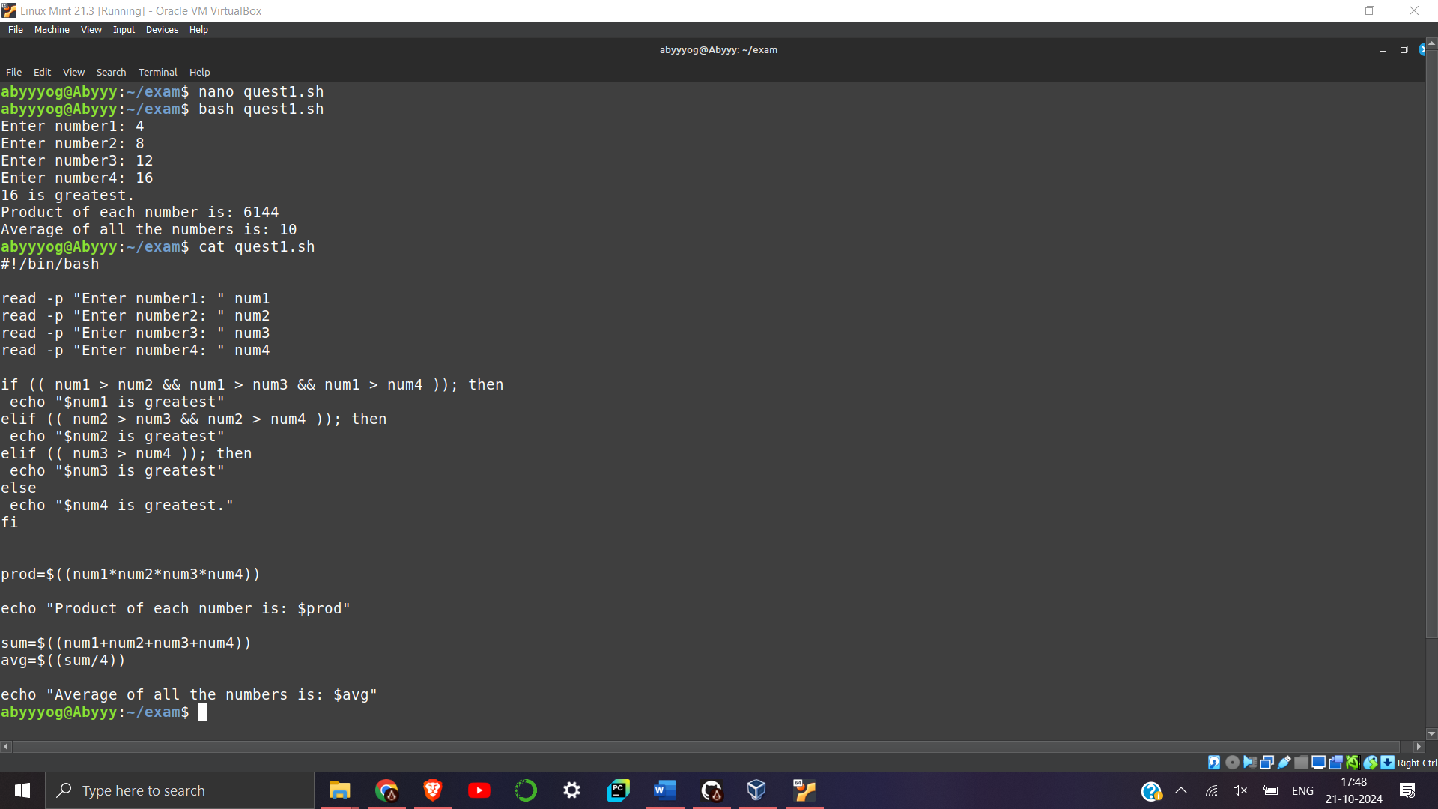

Q2.

a) Create new directory:

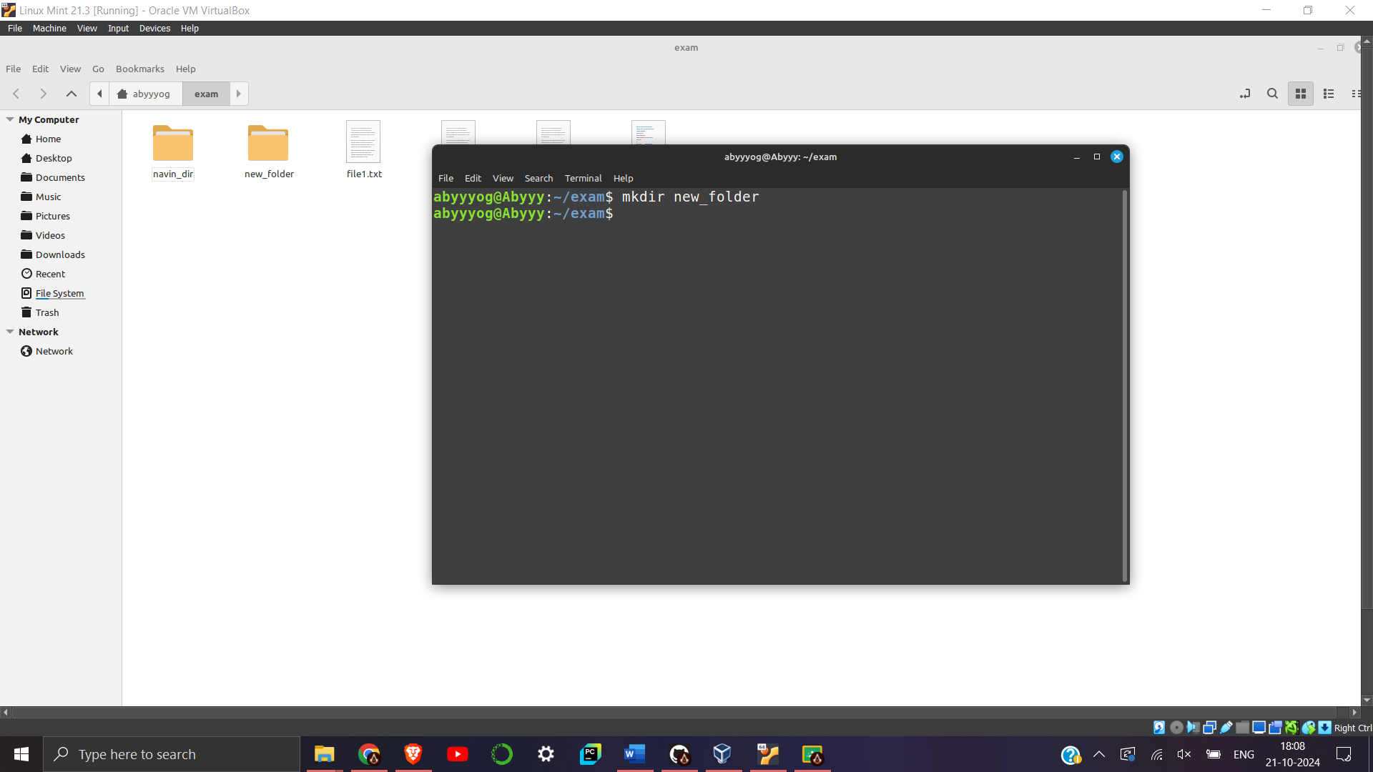

d) Delete an existing directory

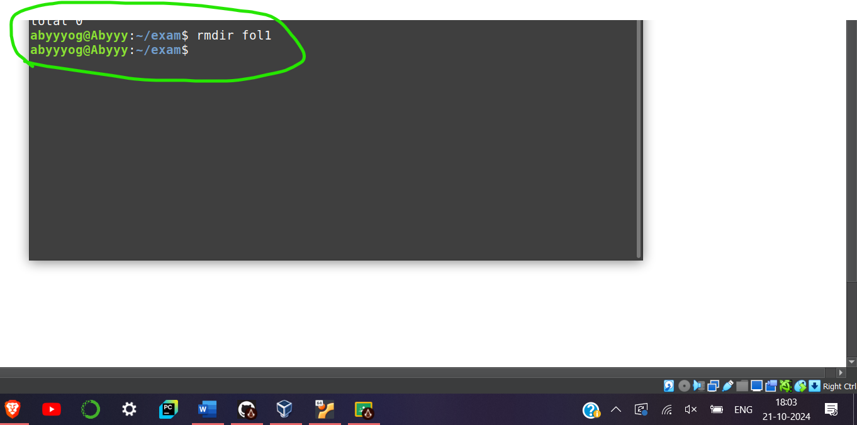

e) creating file file1.txt and hardlink it as “hardl.txt”

